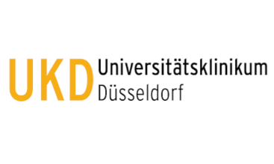

Cardiovascular research laboratory (CVRL) at Universitätsklinikum Düsseldorf offers a master thesis project (m/f/d) with the topic ‘’Pericyte and endothelial interactions in myocardial infarction ‘’

Responsibilities in the project:
- Isolation and characterization of extracellular vesicles
- Co-culture studies, uptake assays
- Cell migration, angiogenesis, cell proliferation assays
The candidates will have the opportunity to work with state-of-the-art equipment in small international group.

Qualification profile
- Background in molecular biology, biochemistry, molecular medicine.
- Willing to learn new techniques such as Nano Particle Tracker, Electron Microscopy, Western blotting, q-RT PCR, cell culture, etc.
- Motivation and curiosity.

We offer
- An exciting research project and the opportunity to learn new techniques
- Gaining valuable theoretical and practical skills in the fields of Vascular biology
- Support for thesis writing and career development suggestions.
If you are interested, forward your CV to Ramesh.chennupati@hhu.de

Dr. Ramesh Chennupati (Jnr. Group Leader)
Universitätsklinikum Düsseldorf
Klinik für Kardiologie, Pneumologie & Angiologie
Director: Prof. Malte Kelm
Gebäude 23.12, Etage E2, Raum 80
Universitätsstr 1
40225 Düsseldorf
Phone: +492118115893

